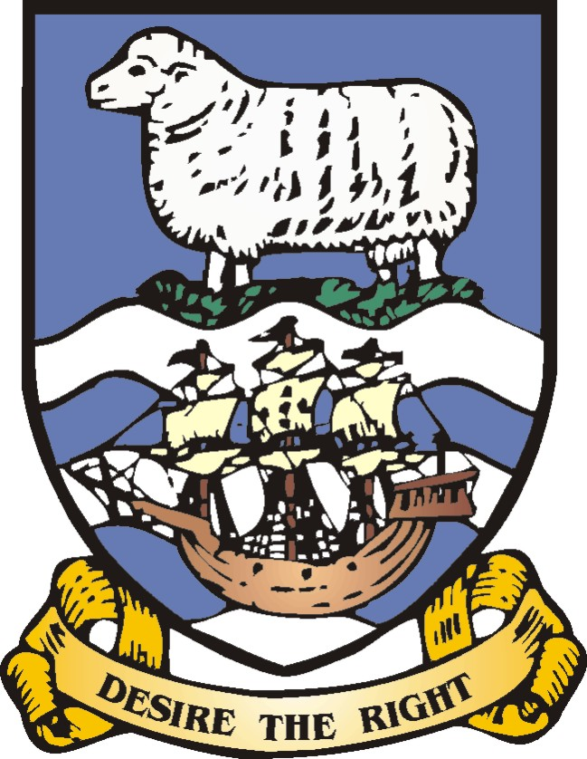

FALKLAND ISLANDS GOVERNMENT

PRESS STATEMENT

21 Sept 2010

Rockhopper Exploration announces preliminary results of well testing in FI 14/10-2 (Sea Lion)

The Falkland Islands Government welcomes Rockhopper Exploration’s announcement regarding well FI 14/10-2 (Sea Lion) in which they state that initial indications from the flow test are positive.

Hon Emma Edwards, Member of the Legislative Assembly, said, “The results from the Sea Lion test represent another positive step in offshore hydrocarbons exploration. However a great deal of work is still required before it can be determined whether a production phase will result. The Falkland Islands Government wishes Rockhopper Exploration well in its onward work programme.”

Office of the Legislative Assembly
Gilbert House
17th Sept 2010

For more information please contact Claudette Prior, Media Liaison Office, Falkland Islands Government at tel. +500 27451 or email media2@sec.gov.fk. Photographs and interviews are available on request, and more Falkland Islands information is available at www.falklands.gov.fk.

Notes to Editors:

The announcement to which this press statement refers can be found on Rockhopper Exploration plc’s website via the following link http://www.rockhopperexploration.co.uk/pdf/Result_of_Flow_Test_FINAL_RNS.pdf

