Falkland Islands Government
The Offshore Petroleum (Licensing) Regulations 2000

- The Governor of the Falkland Islands invites applications, in accordance with the Offshore Petroleum (Licensing) Regulations 2000, for petroleum production licences in respect of whole blocks specified in Schedules 1 and 2 to this notice and delineated on a map deposited at the Department of Mineral Resources, Ross Road, Stanley. An official copy of the map may be inspected between 09.15 and 16.30 hours on Monday to Friday at the above address (contact Tel +500 27322, Fax +500 27321).

Consideration and conditions of Licence

- Licences issued in respect of blocks shown in Schedule 1 and shown on map at Schedule 2 of this notice will be subject to the conditions set out in the Model Clauses for Production Licences in controlled waters (Schedule 2 to the Offshore Petroleum (Licensing) Regulations 2000).

Contiguous whole blocks can be grouped together in single applications, up to a maximum of 30 blocks per application. However, in the case of applications being made for multiple blocks, the Governor reserves the right to make awards of Licences covering only part of that number applied for.

Licences issued in respect of this notice will have an initial exploration term of three or five years, dependent on the nature of the work programme proposed by the applicant (see section 5e below). Fifty percent of the acreage must be relinquished at the end of the first exploration phase. There will be a second exploration period of 3 years, but entry into the second exploration phase will require the submission of a new work programme including the drilling of at least one well.

If a discovery is made, a “Discovery Area” will be identified and set-aside. A Discovery Area can be held for 5 years from the date of spudding of the discovery well, to allow time for appraisal drilling and/or the submission, for the Governor’s approval, of a field development plan. However, either appraisal drilling or the submission of a development plan must commence within three years of the date of a discovery, or the licensee’s interests in the Discovery Area will be forfeited.

An exploitation stage of 35 years, relating only to the area of any defined and exploitable hydrocarbon accumulation, may be entered at any time upon the approval by the Governor of a field development plan.

- The acreage rentals, royalty and profits and gains taxation in respect of Production Licences granted as a result of this invitation will be as follows:

- an acreage rental payment as provided for by the Model Clauses for Production Licences in Controlled Waters, set out within the Offshore Petroleum (Licensing) Regulations 2000;
- a royalty as provided for in the Model Clauses for Production Licences in Controlled Waters, set out within the Offshore Petroleum (Licensing) Regulations 2000, at a rate of 9%.
- Profits and gains from activities carried on in connection with the exploration for and exploitation of petroleum resources within the controlled waters will be subject to Falkland Islands taxation. The current rate for corporation tax is 32.5%.

- Licences may be granted subject to special conditions governing the notice required for, and the timing and circumstances of, operations carried out thereunder (including in particular conditions as to environmental obligations). The Falkland Islands Government will make copies of these conditions available on request and/or as soon as possible.

Applications for Licences

- In respect of blocks shown in Schedule 1 and shown in Schedule 2:

- applications should be made in duplicate in the form available from the Falkland Islands Government’s Mineral Resources Department or in a form substantially to the like effect, and must include in duplicate all materials requested in the application form;
- a third copy of all aspects of the application should be submitted to the British Geological Survey;
- a separate application must be submitted for every group of contiguous blocks, up to a maximum of 30 blocks in any single application;
- applications should be delivered, as either hard copy or on CD-ROM or other computer media as previously agreed with the Director of Mineral Resources, Department of Mineral Resources, Falkland Islands Government, between 09.15 and 16.30 hours on the last working day of any month to, the Director of Mineral Resources, The Department of Mineral Resources, Falkland Islands Government, Ross Road, Stanley, Falkland Islands Fax +500 27321, e-mail oil.fig@horizon.co.fk, together with a remittance in respect of an application fee of £5,000 sterling for each application (to be drawn in Sterling on a UK bank account and payable to the Falkland Islands Government); a copy of the application should also be submitted to Dr P Richards, British Geological Survey, Murchison House, West Mains Road, Edinburgh, EH9 3LA, Scotland, Fax +44 131 668 4930, e-mail pcr@bgs.ac.uk;
- First consideration of bids will be 31 January 2001;
- applicants must provide details of the work programme they propose to carry out if awarded a licence. A work programme must include, as a minimum, one or more of the following elements –

proposals for the acquisition of an extensive and intensive geochemical “sniffer-type” survey;

proposals for the acquisition of an extensive and intensive aeromagnetic survey;

proposals for the acquisition of an extensive and intensive set of sea-bed cores testing the stratigraphy of the feather edges of the presently unexplored basins;

proposals for the acquisition and processing of an extensive and intensive two dimensional or three dimensional seismic survey;

Proposals for the drilling of one or more exploration wells.

Note that Desk Studies and the acquisition of presently available data sets, whether proprietary or non-exclusive will not be regarded as acceptable work commitments.

To qualify for an initial exploration period of five years rather than three, the work programme should include a commitment to acquire and process a seismic programme appropriate to the size of the licensed area, and/or a commitment to drill at least one well during the first five year phase of the licence;

- applicants must provide a statement of their general policy on the environment and (in the case of joint application) state whether this is endorsed by all applicants. Guidance as to the essential elements of an Environmental Policy Statement is available from the Department of Mineral Resources;
- further guidance on the material with which applicants may support their application may be obtained from the Department of Mineral Resources;
- copies of the documents referred to in the text of this notice are available from the Department of Mineral Resources, Ross Road, Stanley, Falkland Islands.

- Applicants will be judged against the background of the Falkland Islands Government’s wish to ensure expeditious, thorough, efficient and safe exploration to identify oil and gas resources on the Falkland Islands Continental Shelf, with due regard to environmental considerations. The financial and technical ability of each applicant will be established as far as possible before the technical aspects of applications are evaluated. Applicants must meet a threshold of acceptability for other criteria, including health and safety and environmental policies. Once these criteria have been met, applicants will be evaluated on the basis of the following technical criteria:

- the quality of the geological analysis related to the blocks applied for and the identification of prospects;
- the quality, extent and scope of the work programme submitted for the first exploration phase;
- the experience and/or technical databases of applicants.

- Applicants achieving the threshold criteria for acceptability outlined in section 6 may be called for interview to discuss the application.

- Following examination of applications, the Governor of the Falkland Islands will select the applicants to whom he is prepared to award licences, and the area that will be covered by those licences should that be less than the entire amount applied for by any applicant.

- The selected applicants will be offered licences on condition that within 14 days of the date on which the Governor of the Falkland Islands makes the offer of an award:

- they will confirm acceptance of a work programme for the first phase of the licence as approved by the Governor following discussion with the applicants concerned;
- they remit to the Governor the appropriate sum referred to in section 3a above; and
- they confirm in writing that they accept any special conditions or restrictions of the sort referred to in section 4 above.

Schedule 1

Standard licence terms will apply to all of the blocks listed below.

The blocks offered, which may be applied for in any combination of whole, contiguous blocks, with a limit of 30 blocks in any one application, are listed below by reference to their Quadrant and/or block numbers. Block co-ordinates are available from the Department of Mineral Resources, Falkland Islands Government, Ross Road, Stanley, Falkland Islands, Tel +500 27322, Fax +500 27321, e-mail oil.fig@horizon.co.fk

Quadrant Blocks

1 All
2 All
3 All
4 All
5 All
6 All
7 All
8 All
9 All
10 All
11 All
12 All
13 All
- 1, 6, 11, 16, 21, 22, 26, 27
- 3, 4, 5, 8, 9 10, 13, 14, 15, 18, 19, 20, 21 to 30 inclusive
- All
- All
- All
- All
- All
- All
- All
- 1 to 15 inclusive
- 1 to 15 inclusive
- 1, 2, 6, 7, 11, 12, 13, 14, 16, 17, 18, 19, 21, 22, 23, 24
- 1 to 10 inclusive, 14, 15, 19, 20, 24, 25
- 1 to 25 inclusive
- All
- All
- All
- All
- All
- All
- All
- All
- All
- All
- All
- All
- 4, 5, 9, 10, 14, 15, 16 to 30 inclusive
- All
- All
- All
- All
- All
- All
- 6, 11 to 30 inclusive
- 3, 4, 5, 7, 8, 9, 10, 11 to 30 inclusive
- All
- All
- All
- All
- All
- All
68 All
- All
- All
- All
- All
- All
- All
- All
- All
- All
- All
- All
- All
- All
- All

Schedule 2

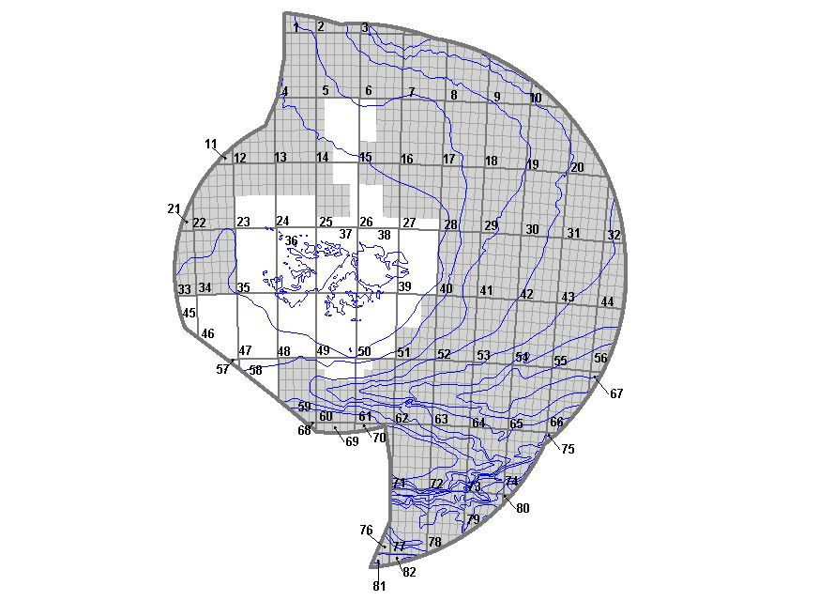
Shaded areas = Blocks available for licensing

