FALKLAND ISLANDS - CMO LETTER

Letter to GP’s/Physicians with information to consider when completing the “Falkland Islands Medical Certificate”, from Dr Rebecca Edwards, Chief Medical Officer (CMO), Falkland Islands.

Dear Doctor,

You have been asked to complete this medical form as your patient hopes to move to the Falkland Islands. To ensure that both you and your patient can make safe choices and decisions, this letter is written to provide you with some information around the medical facilities on the Islands and in particular the limitations of secondary care provision. Please can you read this letter in full.

Background
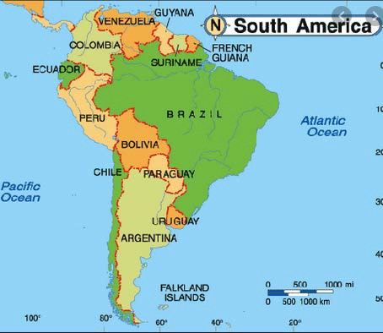
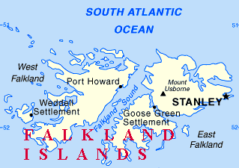

The Falkland Islands is an isolated and sparsely populated British Overseas Territory comprising of an archipelago of two main islands, East and West Falkland and over 776 surrounding smaller islands. The principal islands are about 300 miles (483 kilometers) east of South America's southern Patagonian coast, and about 752 miles (1,210 kilometers) from the northern tip of the Antarctic Peninsula, at a latitude of about 52°S. The population is approximately 3,398 consisting of primarily native-born Falkland Islanders, the majority of British descent.

Healthcare in the Falkland Islands
Medical care is provided by five full-time GPs. There is also one resident consultant general surgeon and consultant anaesthetist who are provided by a British locum agency. Intermittently through the year we have visiting consultant specialists who visit for about a week at a time.

The basic secondary care services on the Islands are provided by the GPs. Some of us have extended skills, e.g. in intrapartum obstetrics, and we can undertake some emergency medical treatments, e.g. cardiac thrombolysis. The hospital here has limited facilities, e.g. we do not have a MRI scanner on the Islands. If a patient becomes critically unwell, or even worryingly unstable, we will aero-med them out to a hospital with more facilities. This is usually to Santiago in Chile, as the Royal Air Force (RAF), who runs the standard UK/FI flight, cannot fly anyone who is deemed medically unstable.

Transferring people out to South America takes a very great deal of time. The fastest we can get an air ambulance into the Islands, collect the patient and back to the main hospital, is about 8-10
hours. Most transfers take an average of 24 hours by the time the decision is made to evacuate. This is often because of limited aircraft availability or poor weather conditions on the Islands.

On rare occasions, when a situation is time-critical, we send patients to Montevideo in Uruguay in an RAF plane, and this transfer window can be achieved in as little as 6 hours, if an aircraft is
available. However we, the GPs, have to provide the medical escort in this scenario (as the British Military here do not have any enhanced medics or physicians on the Islands). We try and avoid using this option for aeromedical evacuation if at all possible because it leaves us with depleted staffing for several days until the team can get back again.

It should also be noted that our aeromedical evacuation facilities are limited to a maximum weight of 120kg. Patients weighing over this may not be able to be evacuated at all.

Acceptable standard of health
As CMO I am asked to assess “the potential burden on healthcare” a patient might present when reviewing their immigration medicals, as such applicants must have an acceptable standard of health. We consider somebody to have an acceptable standard of health if they are:
- Unlikely to be a danger to public health
- Unlikely to impose significant costs or demands on the Falkland Islands health services for treatment and drugs, including aeromedical evacuation costs or special medical services
- Able to carry out the duties for which they have been granted entry.
The list of problems and conditions that cannot be managed in the Islands is not exhaustive, but does include:
- Severe kidney disease (CKD 3b and above)
- Most types of cancers
- Haemophilia – or other complex blood disorders
- Severe osteoporosis
- Relapsing or remitting / complex neurological disorders
- Complex and unstable autoimmune conditions
- HIV infection
- Untreated infectious diseases (e.g. hepatitis or TB)
- Poorly controlled diabetes –type one or two
- Severe / chronic / complex cardiac conditions
- Severe / chronic / complex lung disease
- Severe / chronic liver disease
- Patients who have had organ transplants
- Severe Obesity (weight over 140gk)
- Serious Mental Illness
- Pregnant women with complex obstetric histories

Please ask yourself if you think it is safe for your patient to be cared for here where we have very limited access to secondary care and emergency medical treatment.
If your patient has a chronic or complex medical or mental health condition that requires regular

monitoring, or has a condition that has the potential to deteriorate to such an extent that it will be unable to be managed within the islands medical services, it is advisable to highlight this early on in the application process. Direct contact with me to discuss issues, prior to commencement and processing of the application process, is recommended. I can be contacted via cmo@kemh.gov.fk

Many thanks for reading this information guide, please contact me if you have questions or concerns.
Dr Rebecca Edwards OBE
Chief Medical Officer, Falkland Islands

